**Assignment 1**

Q1. Create vector a = c(4,17,7,4,6,8,9,15,17,20)

1. Find its Mean
2. Median (R does not have its default function) Search and write a function.
3. Mode
4. Variance
5. Standard Deviation

Q2. Create a matrix of 3X3 with elements starting from 21:29

1. Find its diagonal Elements
2. Find the lower diagonal element
3. Find the lower diagonal element excluding the diagonal elements
4. Find the upper diagonal elements
5. Find the upper diagonal elements excluding the diagonal elements

Q3. Crate a matrix 2X2 (confusion matrix) as shown below

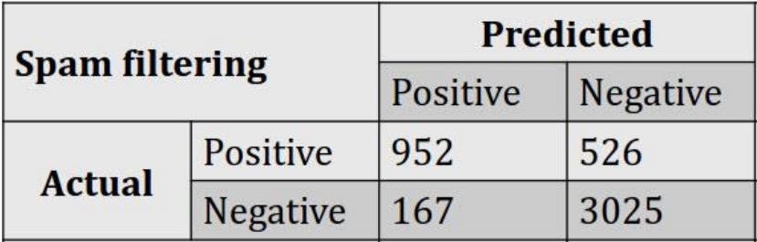

1. Create a matrix with the elements provided
2. Based on the formula find Accuracy, Recall, Specificity using R
3. Accuracy -> select the diagonal elements to that of sum of all elements
4. Recall -> Ratio of ( True +ve / Total Actual Positive)
5. Specificity -> Ratio ( True -ve / Total Actual negative)
6. Precision -> Ratio(True +ve/ Total Predicted Positive)

Reference: Please follow the below diagram.

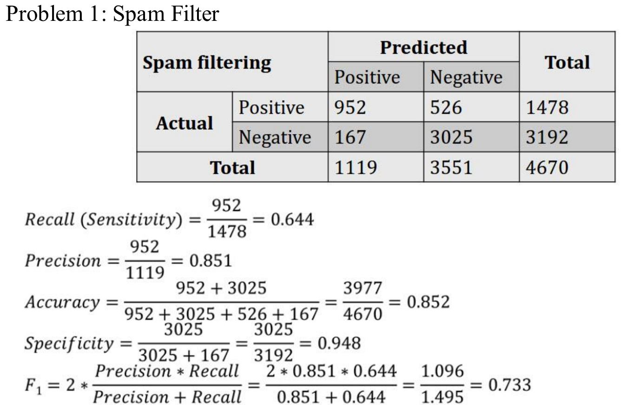

Q4. Create a List of Employee Information Add as much as information you can guess.

1. Create List
2. Access the elements of the list
3. Delete the elements of the list
4. Update the elements of the list

Q5. Create a Data Frame of Cricketers or which you like but should have categorical & Numerical values.

Eg: For Cricketers

(Name, Team, Type of player (batsman or baller), No of runs, No of wickets, Is Captain( Yes or No), Matches Played)

1. Add at least 15 records
2. Access the head elements
3. Access the tail elements
4. Access specific row
5. Access specific column
6. Delete a row
7. Delete a specific column
8. Delete entire row based on name of cricketer
9. Update the records

Q6. Import the data from a json file (Code is given just try importing)

1. install.packages('rjson')
2. library("rjson")
3. json_file <- "http://api.worldbank.org/country?per_page=10&region=OED&lendingtype=LNX&format=json"
4. json_data <- fromJSON(file=json_file)
5. json_data = as.data.frame(json_data)

Q7. Try to install SQL/Oracle or My SQL and import the data into R and specify the Query or command you use to import the data into R.